N = 10

Pi = 4.000000

Pi = 4.000000

Pi = 2.400000

Pi = 2.400000

Pi = 3.200000

Pi = 3.200000

Pi = 3.600000

Pi = 3.200000

Pi = 2.800000

Pi = 2.800000

Mean = 3. 3.060000

Standard Deviation = 0.620000

%%%%%%%%%%%%%%%%%%%%%%%%%%%%%%%%%%%%%%%%%%%%%%%%%%%%%%

N = 100

Pi = 3.000000

Pi = 3.400000

Pi = 3.360000

Pi = 3.080000

Pi = 3.000000

Pi = 3.200000

Pi = 3.200000

Pi = 2.920000

Pi = 3.240000

Pi = 3.360000

Mean = 3.176000

Standard Deviation = 0.161196

%%%%%%%%%%%%%%%%%%%%%%%%%%%%%%%%%%%%%%%%%%%%%%%%%%%%%%

N = 1000

Pi = 3.120000

Pi = 3.052000

Pi = 3.136000

Pi = 3.140000

Pi = 3.196000

Pi = 3.168000

Pi = 3.212000

Pi = 3.164000

Pi = 3.136000

Pi = 3.176000

Mean = 3.150000

Standard Deviation = 0.042605

%%%%%%%%%%%%%%%%%%%%%%%%%%%%%%%%%%%%%%%%%%%%%%%%%%%%%%

N = 100000

Pi = 3.132120

Pi = 3.143960

Pi = 3.143440

Pi = 3.148280

Pi = 3.134720

Pi = 3.141800

Pi = 3.140960

Pi = 3.145720

Pi = 3.143200

Pi = 3.144920

Mean = 3.141912

Standard Deviation = 0.004699

%%%%%%%%%%%%%%%%%%%%%%%%%%%%%%%%%%%%%%%%%%%%%%%%%%%%%%

N = 1000000

Pi = 3.142244

Pi = 3.140948

Pi = 3.140520

Pi = 3.141608

Pi = 3.142768

Pi = 3.141052

Pi = 3.141264

Pi = 3.142072

Pi = 3.135720

Pi = 3.140436

Mean = 3.140863

Standard Deviation = 0.001858

%%%%%%%%%%%%%%%%%%%%%%%%%%%%%%%%%%%%%%%%%%%%%%%%%%%%%%

N = 10000000

Pi = 3.141286

Pi = 3.140210

Pi = 3.141008

Pi = 3.141914

Pi = 3.141324

Pi = 3.141626

Pi = 3.141693

Pi = 3.141966

Pi = 3.142298

Pi = 3.141510

Mean = 3.141484

Standard Deviation = 0.000553

%%%%%%%%%%%%%%%%%%%%%%%%%%%%%%%%%%%%%%%%%%%%%%%%%%%%%%

N = 100000000

Pi = 3.141269

Pi = 3.141788

Pi = 3.141474

Pi = 3.141617

Pi = 3.141602

Pi = 3.141610

Pi = 3.141564

Pi = 3.141331

Pi = 3.141776

Pi = 3.141775

Mean = 3.141581

Standard Deviation = 0.000171

%%%%%%%%%%%%%%%%%%%%%%%%%%%%%%%%%%%%%%%%%%%%%%%%%%%%%%

As the N value increases, the Values of Pi become more accurate, the mean converges on the actual Pi value, and the standard deviation value decreases.

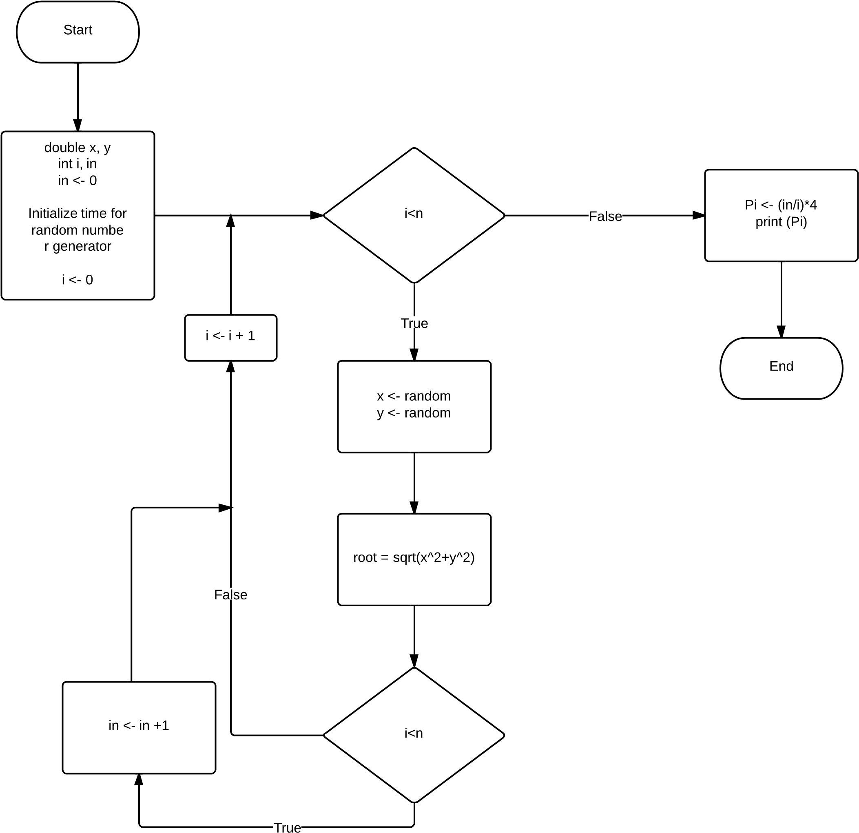



**obelix[64]% gcc prog2.c**

**obelix[65]% a.out**

**Enter n value:100** <-- These show that the following values

**Enter n value:133** are incorrect input values.

**Enter n value:60** The user is prompted again for

**Enter n value:0**  a value.

**Enter n value:3**  <-- Correct input value

8 1 6

3 5 7

4 9 2

%%%%%%%%%%%%%%%%%%%%%%%%%%%%%%%%%%%%%%%%%%%%%%%%%%%%%%

**obelix[67]% a.out**

**Enter n value:1**

1

%%%%%%%%%%%%%%%%%%%%%%%%%%%%%%%%%%%%%%%%%%%%%%%%%%%%%%

**obelix[68]% a.out**

**Enter n value:7**

30 39 48 1 10 19 28

38 47 7 9 18 27 29

46 6 8 17 26 35 37

5 14 16 25 34 36 45

13 15 24 33 42 44 4

21 23 32 41 43 3 12

22 31 40 49 2 11 20

%%%%%%%%%%%%%%%%%%%%%%%%%%%%%%%%%%%%%%%%%%%%%%%%%%%%%%

**obelix[68]% a.out**

**Enter n value:5**

17 24 1 8 15

23 5 7 14 16

4 6 13 20 22

10 12 19 21 3

11 18 25 2 9

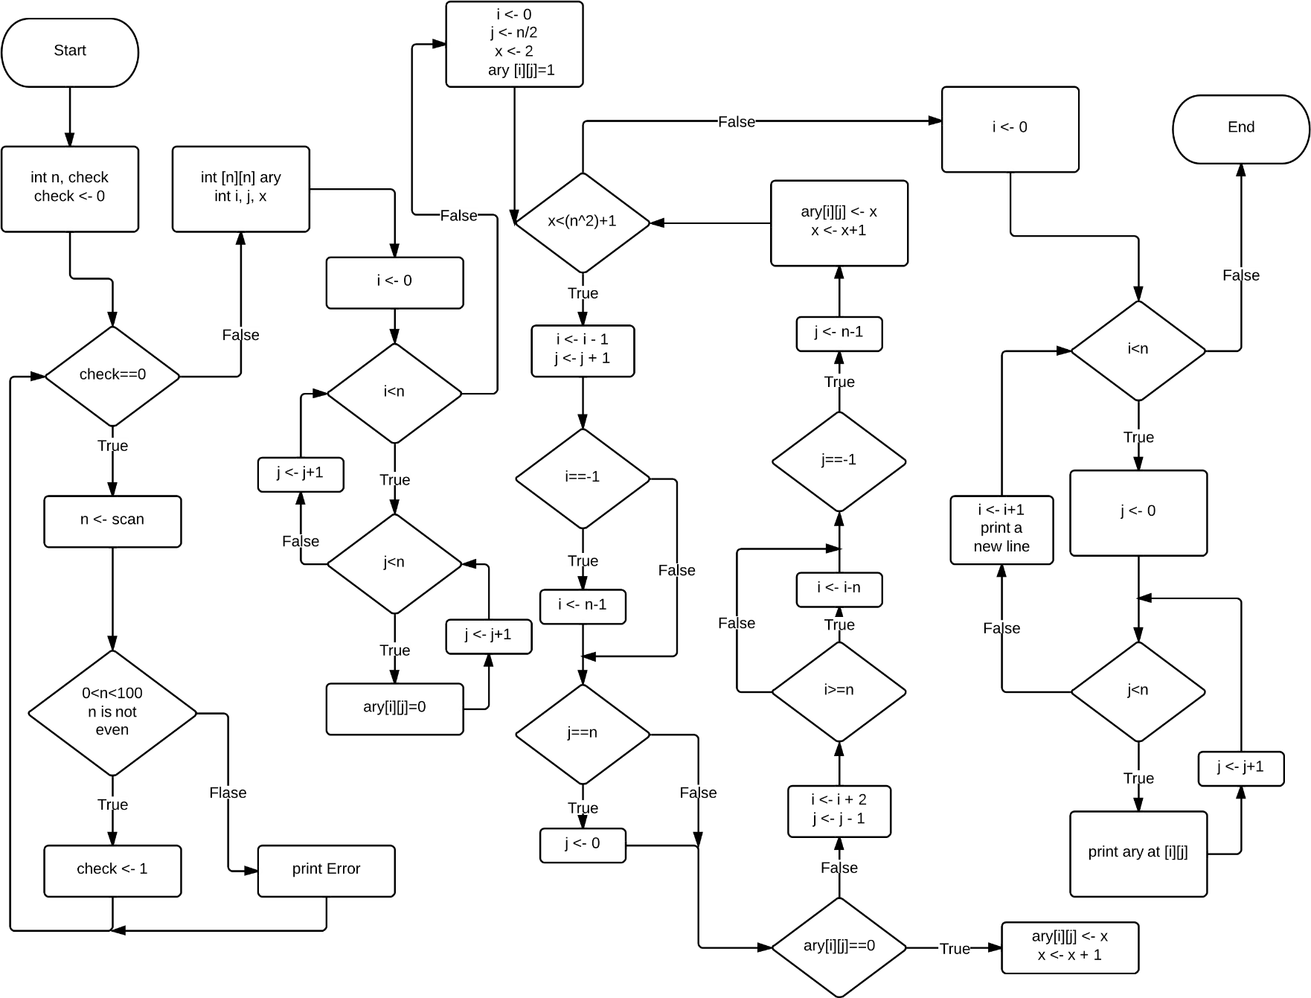



**obelix[13]% a.out**

**Enter the amount in dollars: 1**

The smallest number of $20-$1 bills/coins necessary to pay the dollar amount: 1

0 20$, 0 10$, 0 5$, 0 2$, 1 1$  
  
%%%%%%%%%%%%%%%%%%%%%%%%%%%%%%%%%%%%%%%%%%%%%%%%%%%%%%%%%%%

**obelix[14]% a.out**

**Enter the amount in dollars: 2**

The smallest number of $20-$1 bills/coins necessary to pay the dollar amount: 2

0 20$, 0 10$, 0 5$, 1 2$, 0 1$

%%%%%%%%%%%%%%%%%%%%%%%%%%%%%%%%%%%%%%%%%%%%%%%%%%%%%%%%%%%

**obelix[15]% a.out**

**Enter the amount in dollars: 3**

The smallest number of $20-$1 bills/coins necessary to pay the dollar amount: 3

0 20$, 0 10$, 0 5$, 1 2$, 1 1$

%%%%%%%%%%%%%%%%%%%%%%%%%%%%%%%%%%%%%%%%%%%%%%%%%%%%%%%%%%%

**obelix[18]% a.out**

**Enter the amount in dollars: 4**

The smallest number of $20-$1 bills/coins necessary to pay the dollar amount: 4

0 20$, 0 10$, 0 5$, 2 2$, 0 1$

%%%%%%%%%%%%%%%%%%%%%%%%%%%%%%%%%%%%%%%%%%%%%%%%%%%%%%%%%%%

**obelix[19]% a.out**

**Enter the amount in dollars: 5**

The smallest number of $20-$1 bills/coins necessary to pay the dollar amount: 5

0 20$, 0 10$, 1 5$, 0 2$, 0 1$

%%%%%%%%%%%%%%%%%%%%%%%%%%%%%%%%%%%%%%%%%%%%%%%%%%%%%%%%%%%  
  
**obelix[30]% a.out**

**Enter the amount in dollars: 10**

The smallest number of $20-$1 bills/coins necessary to pay the dollar amount: 10

0 20$, 1 10$, 0 5$, 0 2$, 0 1$

%%%%%%%%%%%%%%%%%%%%%%%%%%%%%%%%%%%%%%%%%%%%%%%%%%%%%%%%%%%

**obelix[31]% a.out**

**Enter the amount in dollars: 20**

The smallest number of $20-$1 bills/coins necessary to pay the dollar amount: 20

1 20$, 0 10$, 0 5$, 0 2$, 0 1$

%%%%%%%%%%%%%%%%%%%%%%%%%%%%%%%%%%%%%%%%%%%%%%%%%%%%%%%%%%%

**obelix[32]% a.out**

**Enter the amount in dollars: 30**

The smallest number of $20-$1 bills/coins necessary to pay the dollar amount: 30

1 20$, 1 10$, 0 5$, 0 2$, 0 1$

%%%%%%%%%%%%%%%%%%%%%%%%%%%%%%%%%%%%%%%%%%%%%%%%%%%%%%%%%%%

**obelix[33]% a.out**

**Enter the amount in dollars: 524132**

The smallest number of $20-$1 bills/coins necessary to pay the dollar amount: 524132

26206 20$, 1 10$, 0 5$, 1 2$, 0 1$

%%%%%%%%%%%%%%%%%%%%%%%%%%%%%%%%%%%%%%%%%%%%%%%%%%%%%%%%%%%

**obelix[34]% a.out**

**Enter the amount in dollars: 765**

The smallest number of $20-$1 bills/coins necessary to pay the dollar amount: 765

38 20$, 0 10$, 1 5$, 0 2$, 0 1$

